CWB Third Party Information Security Clauses – Plus Excerpts from the Temenos Software Agreement Addendum for Digital

Information Security. Third Party will at all times employ reasonable information security measures to protect Canadian Western Bank’s information (the “Security Measures”), including, but not limited to, those measures set out in Schedule “A” of this Agreement. Canadian Western Bank may, upon notice in writing, audit the Security Measures or request information relating to the Security Measures, including, independent audit and assurance reports generated by Third Party’s review of its information systems. Information Systems refers to information technology, processes and resources used in the collection, processing, storage, use, sharing, dissemination and disposal of information.

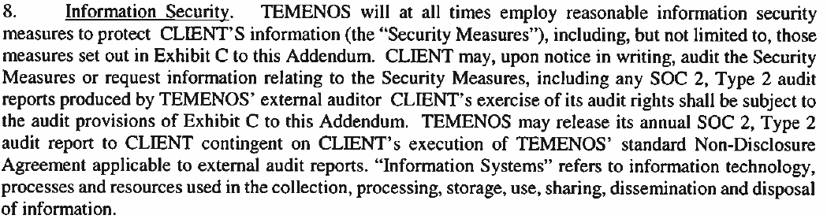

SCHEDULE “A” – INFORMATION SECURITY

Information Oversight. All Canadian Western Bank information stored and processed by Third Party in electronic format shall be governed by reasonable oversight, audit and assurance mechanisms, duly employing documented policies, processes and procedures.
Data Storage, Processing, Recovery. All Canadian Western Bank information stored by Third Party in electronic format shall be stored logically separate from the data of other Third Party clients and in a manner that restricts access to third parties and employees who have a need to know the information.
Data Protection. All Canadian Western Bank information stored and transmitted Third Party in electronic format shall be protected using a robust information security architecture that includes networks, firewalls and / or other boundary protection equipment, and current industry standard encryption mechanisms

Incident Response: Third Party will maintain a formal Incident Response mechanism for the purpose of identifying, responding to, containing, and recovering from, an information security incident. Third Party will ensure the appropriate training of personnel responsible for executing the Incident Response Plan and that regular testing of the plan occurs.
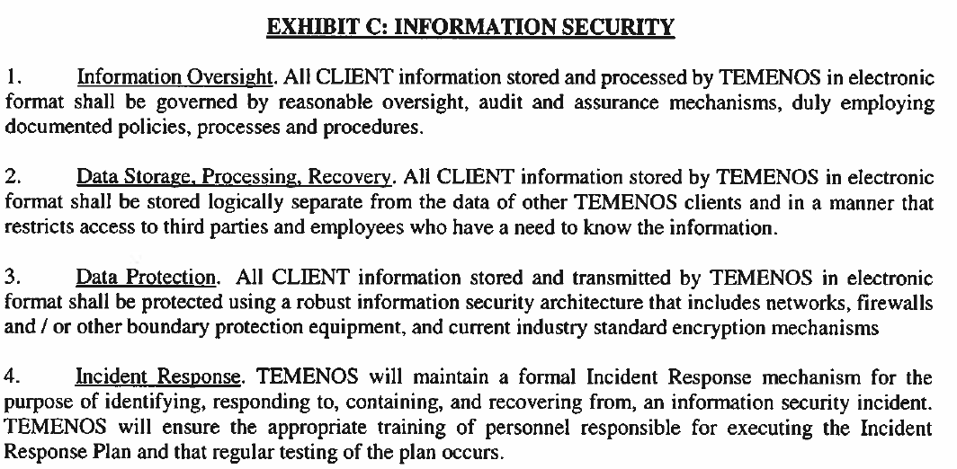

Breach Notification: Third Party will notify Canadian Western Bank as soon as it is determined that an information security breach of Third Party has occurred, impacting and / or compromising the confidentiality, integrity, or availability of Canadian Western Bank’s information stored and processed by Third Party. Canadian Western Bank reserves the right to review and / or audit and / or undertake an independent assessment of the breach. Third Party agrees to cooperate and assist Canadian Western Bank in such investigations.

Information Retirement. Third Party agrees that it shall retire or destroy Canadian Western Bank’s information in its custody, in accordance with the data retention requirements under Canadian Laws, and, Canadian Western Bank’s data retention guidelines, as applicable.

Regulations and Governance. The use and disclosure of Canadian Western Bank information obtained by Third Party under this Agreement shall be subject to applicable laws, including the Personal Information Protection and Electronic Documents Act (PIPEDA), and, Canadian Western Bank’s Information Security policies governing Canadian Western Bank’s relationships with Third Parties and Vendors.
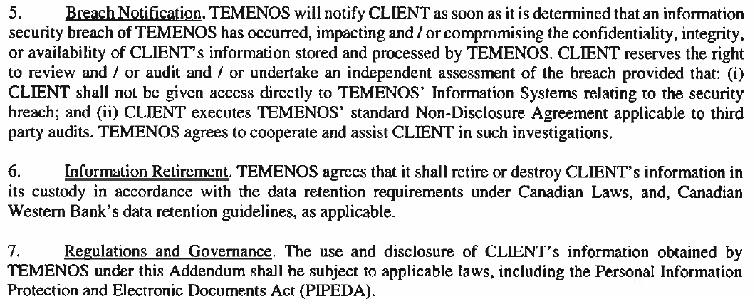
Materiality of Loss arising from Incidents related to Information Security Incidents. Canadian Western Bank shall determine materiality of loss from incidents related to information security on its information stored and processed by Third Party, in a manner that aligns with Canadian Western Bank’s Enterprise Risk practices. The Third Party agrees to pay for costs incurred by Canadian Western Bank in investigating and addressing the information security incidents.

Information Disclosure. Except as required under Canadian Laws, Third Party shall not disclose or share Canadian Western Bank’s information held in its custody, in part or in full, to any other party (or parties) without an explicit authorization from Canadian Western Bank. Information disclosure shall remain in effect as long as Third Party holds Canadian Western Bank’s information in its custody, irrespective of this Agreement being in effect, or has expired.

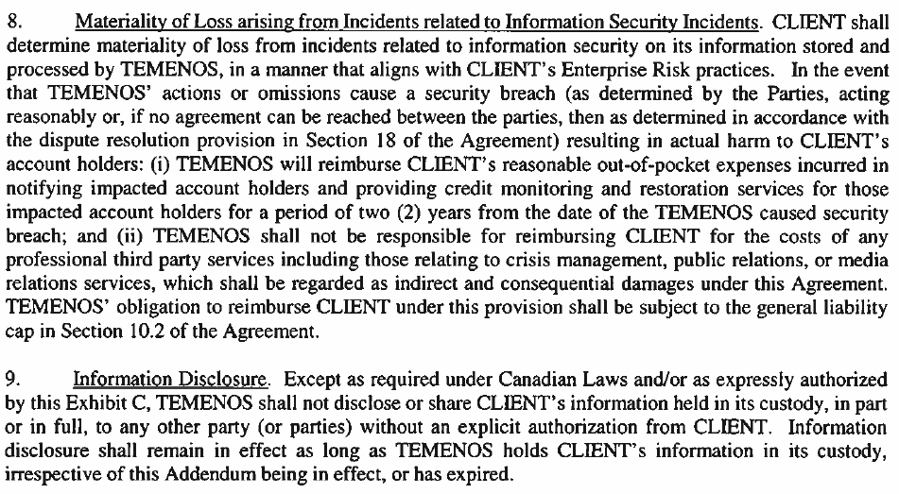

Information Storage Outside of Canada. Third Party agrees that it shall make all reasonable effort to store Canadian Western Bank’s information within Canada. If Third Party intends to store and/or process Canadian Western Bank’s information outside Canada, then it shall first notify Canadian Western Bank about its data storage facilities including physical address of the location. Third Party agrees that it shall be liable for all applicable Canadian Laws and Regulations governing Canadian Financial Institutions’ information processing guidelines outside of Canada.
